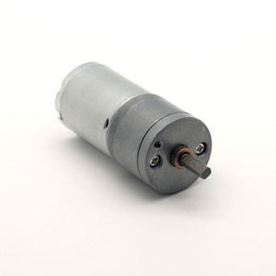

#### LDO-25GM370 Series

**SPECIFICATIONS:**

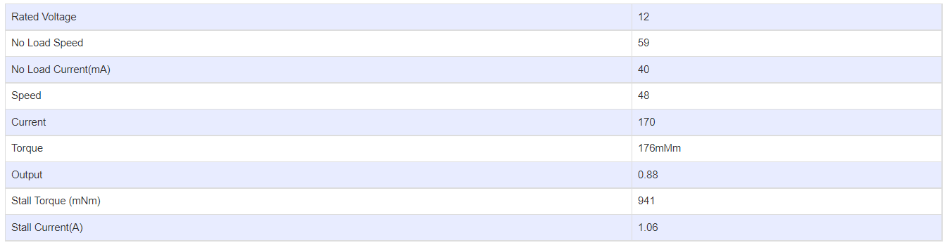

**GEARBOX OPTIONS:**

